Tutorial – 5

- Design a Form like below. When user Click on OK Button it will print “Welcome to First Windows Application” on Label. When User Click on Cancel button form get closed.
using System;
using System.Collections.Generic;
using System.ComponentModel;
using System.Data;
using System.Drawing;
using System.Linq;
using System.Text;
using System.Threading.Tasks;
using System.Windows.Forms;

namespace pahliBar
{
public partial class P1 : Form
{
public P1()
{
InitializeComponent();
}

private void okBtn_Click(object sender, EventArgs e)
{
label1.Visible = true;
label1.Text = "Welcome to first application";
}

private void cancelBtn_Click(object sender, EventArgs e)
{
this.Hide();

}
}
}

Output:-
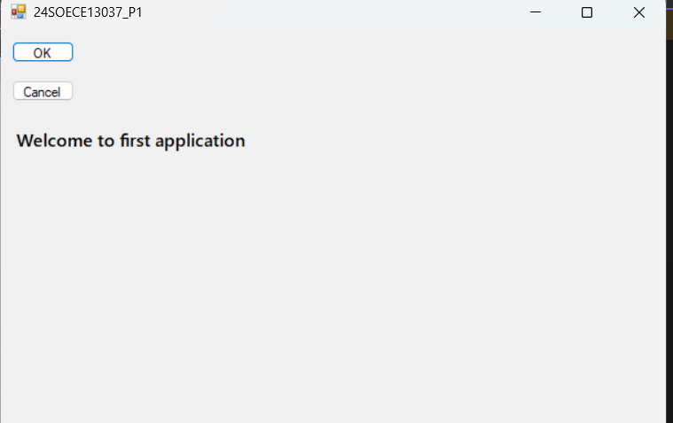

- Design a Form like below. When user click on Send Message Button it will display combine message like below on label:“Message of <<Name>> from <<Organization>> with <<comment>>”
namespace First_Desktop_App
{
partial class Form1
{
/// <summary>
/// Required designer variable.
/// </summary>
private System.ComponentModel.IContainer components = null;

/// <summary>
/// Clean up any resources being used.
/// </summary>
/// <param name="disposing">true if managed resources should be disposed; otherwise, false.</param>
protected override void Dispose(bool disposing)
{
if (disposing && (components != null))
{
components.Dispose();
}
base.Dispose(disposing);
}

#region Windows Form Designer generated code

/// <summary>
/// Required method for Designer support - do not modify
/// the contents of this method with the code editor.
/// </summary>
private void InitializeComponent()
{
this.textBox1 = new System.Windows.Forms.TextBox();
this.textBox2 = new System.Windows.Forms.TextBox();
this.label1 = new System.Windows.Forms.Label();
this.label3 = new System.Windows.Forms.Label();
this.label4 = new System.Windows.Forms.Label();
this.ENTER_BTN = new System.Windows.Forms.Button();
this.label2 = new System.Windows.Forms.Label();
this.label5 = new System.Windows.Forms.Label();
this.SuspendLayout();
//
// textBox1
//
this.textBox1.Location = new System.Drawing.Point(345, 119);
this.textBox1.Name = "textBox1";
this.textBox1.Size = new System.Drawing.Size(100, 22);
this.textBox1.TabIndex = 0;
//
// textBox2
//
this.textBox2.Location = new System.Drawing.Point(345, 166);
this.textBox2.Name = "textBox2";
this.textBox2.Size = new System.Drawing.Size(100, 22);
this.textBox2.TabIndex = 1;
//
// label1
//
this.label1.AutoSize = true;
this.label1.Font = new System.Drawing.Font("Microsoft Sans Serif", 15F, System.Drawing.FontStyle.Bold, System.Drawing.GraphicsUnit.Point, ((byte)(0)));
this.label1.Location = new System.Drawing.Point(215, 48);
this.label1.Name = "label1";
this.label1.Size = new System.Drawing.Size(393, 29);
this.label1.TabIndex = 2;
this.label1.Text = "THIS IS MY 1ST APPLICATION";
this.label1.Click += new System.EventHandler(this.label1_Click);
//
// label3
//
this.label3.AutoSize = true;
this.label3.Location = new System.Drawing.Point(255, 122);
this.label3.Name = "label3";
this.label3.Size = new System.Drawing.Size(78, 16);
this.label3.TabIndex = 4;
this.label3.Text = "Enter Name";
this.label3.Click += new System.EventHandler(this.label3_Click);
//
// label4
//
this.label4.AutoSize = true;
this.label4.Location = new System.Drawing.Point(255, 172);
this.label4.Name = "label4";
this.label4.Size = new System.Drawing.Size(63, 16);
this.label4.TabIndex = 5;
this.label4.Text = "Enter CIty";
this.label4.Click += new System.EventHandler(this.label4_Click);
//
// ENTER_BTN
//
this.ENTER_BTN.Location = new System.Drawing.Point(345, 228);
this.ENTER_BTN.Name = "ENTER_BTN";
this.ENTER_BTN.Size = new System.Drawing.Size(75, 23);
this.ENTER_BTN.TabIndex = 6;
this.ENTER_BTN.Text = "ENTER";
this.ENTER_BTN.UseVisualStyleBackColor = true;
this.ENTER_BTN.Click += new System.EventHandler(this.ENTER_BTN_Click);
//
// label2
//
this.label2.AutoSize = true;
this.label2.Location = new System.Drawing.Point(353, 279);
this.label2.Name = "label2";
this.label2.Size = new System.Drawing.Size(0, 16);
this.label2.TabIndex = 7;
this.label2.Click += new System.EventHandler(this.label2_Click);
//
// label5
//
this.label5.AutoSize = true;
this.label5.Location = new System.Drawing.Point(302, 279);
this.label5.Name = "label5";
this.label5.Size = new System.Drawing.Size(0, 16);
this.label5.TabIndex = 8;
this.label5.Visible = false;
//
// Form1
//
this.AutoScaleDimensions = new System.Drawing.SizeF(8F, 16F);
this.AutoScaleMode = System.Windows.Forms.AutoScaleMode.Font;
this.ClientSize = new System.Drawing.Size(800, 450);
this.Controls.Add(this.label5);
this.Controls.Add(this.label2);
this.Controls.Add(this.ENTER_BTN);
this.Controls.Add(this.label4);
this.Controls.Add(this.label3);
this.Controls.Add(this.label1);
this.Controls.Add(this.textBox2);
this.Controls.Add(this.textBox1);
this.Name = "Form1";
this.Text = "a";
this.Load += new System.EventHandler(this.Form1_Load);
this.ResumeLayout(false);
this.PerformLayout();

}

#endregion

private System.Windows.Forms.TextBox textBox1;
private System.Windows.Forms.TextBox textBox2;
private System.Windows.Forms.Label label1;
private System.Windows.Forms.Label label3;
private System.Windows.Forms.Label label4;
private System.Windows.Forms.Button ENTER_BTN;
private System.Windows.Forms.Label label2;
private System.Windows.Forms.Label label5;
}
}
Output:-
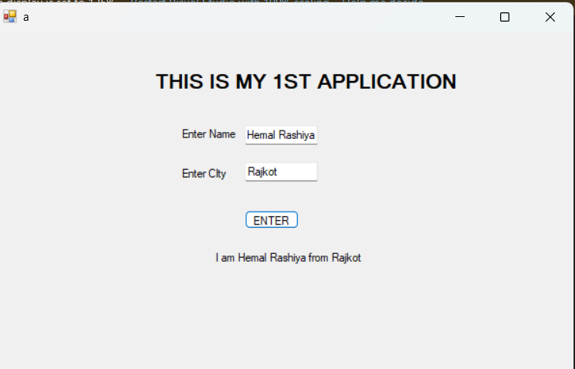

- Design a form like below. Depends on User’s selection, Background color and ForeColor of Form will change.

namespace pahliBar
{
partial class Form3
{
/// <summary>
/// Required designer variable.
/// </summary>
private System.ComponentModel.IContainer components = null;

/// <summary>
/// Clean up any resources being used.
/// </summary>
/// <param name="disposing">true if managed resources should be disposed; otherwise, false.</param>
protected override void Dispose(bool disposing)
{
if (disposing && (components != null))
{
components.Dispose();
}
base.Dispose(disposing);
}

#region Windows Form Designer generated code

/// <summary>
/// Required method for Designer support - do not modify
/// the contents of this method with the code editor.
/// </summary>
private void InitializeComponent()
{
this.radioButton1 = new System.Windows.Forms.RadioButton();
this.radioButton2 = new System.Windows.Forms.RadioButton();
this.radioButton3 = new System.Windows.Forms.RadioButton();
this.radioButton4 = new System.Windows.Forms.RadioButton();
this.radioButton5 = new System.Windows.Forms.RadioButton();
this.radioButton6 = new System.Windows.Forms.RadioButton();
this.groupBox1 = new System.Windows.Forms.GroupBox();
this.groupBox2 = new System.Windows.Forms.GroupBox();
this.groupBox1.SuspendLayout();
this.groupBox2.SuspendLayout();
this.SuspendLayout();
//
// radioButton1
//
this.radioButton1.AutoSize = true;
this.radioButton1.Location = new System.Drawing.Point(10, 22);
this.radioButton1.Name = "radioButton1";
this.radioButton1.Size = new System.Drawing.Size(48, 20);
this.radioButton1.TabIndex = 0;
this.radioButton1.TabStop = true;
this.radioButton1.Text = "red";
this.radioButton1.UseVisualStyleBackColor = true;
this.radioButton1.CheckedChanged += new System.EventHandler(this.radioButton1_CheckedChanged);
//
// radioButton2
//
this.radioButton2.AutoSize = true;
this.radioButton2.Location = new System.Drawing.Point(184, 22);
this.radioButton2.Name = "radioButton2";
this.radioButton2.Size = new System.Drawing.Size(54, 20);
this.radioButton2.TabIndex = 1;
this.radioButton2.TabStop = true;
this.radioButton2.Text = "blue";
this.radioButton2.UseVisualStyleBackColor = true;
this.radioButton2.CheckedChanged += new System.EventHandler(this.radioButton2_CheckedChanged);
//
// radioButton3
//
this.radioButton3.AutoSize = true;
this.radioButton3.Location = new System.Drawing.Point(374, 21);
this.radioButton3.Name = "radioButton3";
this.radioButton3.Size = new System.Drawing.Size(63, 20);
this.radioButton3.TabIndex = 2;
this.radioButton3.TabStop = true;
this.radioButton3.Text = "green";
this.radioButton3.UseVisualStyleBackColor = true;
this.radioButton3.CheckedChanged += new System.EventHandler(this.radioButton3_CheckedChanged);
//
// radioButton4
//
this.radioButton4.AutoSize = true;
this.radioButton4.Location = new System.Drawing.Point(10, 37);
this.radioButton4.Name = "radioButton4";
this.radioButton4.Size = new System.Drawing.Size(57, 20);
this.radioButton4.TabIndex = 5;
this.radioButton4.TabStop = true;
this.radioButton4.Text = "cyan";
this.radioButton4.UseVisualStyleBackColor = true;
this.radioButton4.CheckedChanged += new System.EventHandler(this.radioButton4_CheckedChanged);
//
// radioButton5
//
this.radioButton5.AutoSize = true;
this.radioButton5.Location = new System.Drawing.Point(184, 36);
this.radioButton5.Name = "radioButton5";
this.radioButton5.Size = new System.Drawing.Size(53, 20);
this.radioButton5.TabIndex = 6;
this.radioButton5.TabStop = true;
this.radioButton5.Text = "pink";
this.radioButton5.UseVisualStyleBackColor = true;
this.radioButton5.CheckedChanged += new System.EventHandler(this.radioButton5_CheckedChanged);
//
// radioButton6
//
this.radioButton6.AutoSize = true;
this.radioButton6.Location = new System.Drawing.Point(374, 35);
this.radioButton6.Name = "radioButton6";
this.radioButton6.Size = new System.Drawing.Size(61, 20);
this.radioButton6.TabIndex = 7;
this.radioButton6.TabStop = true;
this.radioButton6.Text = "black";
this.radioButton6.UseVisualStyleBackColor = true;
this.radioButton6.CheckedChanged += new System.EventHandler(this.radioButton6_CheckedChanged);
//
// groupBox1
//
this.groupBox1.Controls.Add(this.radioButton6);
this.groupBox1.Controls.Add(this.radioButton4);
this.groupBox1.Controls.Add(this.radioButton5);
this.groupBox1.Location = new System.Drawing.Point(42, 140);
this.groupBox1.Name = "groupBox1";
this.groupBox1.Size = new System.Drawing.Size(560, 79);
this.groupBox1.TabIndex = 8;
this.groupBox1.TabStop = false;
this.groupBox1.Text = "Fore Color";
this.groupBox1.Enter += new System.EventHandler(this.groupBox1_Enter);
//
// groupBox2
//
this.groupBox2.Controls.Add(this.radioButton3);
this.groupBox2.Controls.Add(this.radioButton1);
this.groupBox2.Controls.Add(this.radioButton2);
this.groupBox2.Location = new System.Drawing.Point(42, 39);
this.groupBox2.Name = "groupBox2";
this.groupBox2.Size = new System.Drawing.Size(560, 65);
this.groupBox2.TabIndex = 9;
this.groupBox2.TabStop = false;
this.groupBox2.Text = "Back Color";
this.groupBox2.Enter += new System.EventHandler(this.groupBox2_Enter);
//
// Form3
//
this.AutoScaleDimensions = new System.Drawing.SizeF(8F, 16F);
this.AutoScaleMode = System.Windows.Forms.AutoScaleMode.Font;
this.ClientSize = new System.Drawing.Size(800, 450);
this.Controls.Add(this.groupBox2);
this.Controls.Add(this.groupBox1);
this.Name = "Form3";
this.Text = "Form3";
this.groupBox1.ResumeLayout(false);
this.groupBox1.PerformLayout();
this.groupBox2.ResumeLayout(false);
this.groupBox2.PerformLayout();
this.ResumeLayout(false);

}

#endregion

private System.Windows.Forms.RadioButton radioButton1;
private System.Windows.Forms.RadioButton radioButton2;
private System.Windows.Forms.RadioButton radioButton3;
private System.Windows.Forms.RadioButton radioButton4;
private System.Windows.Forms.RadioButton radioButton5;
private System.Windows.Forms.RadioButton radioButton6;
private System.Windows.Forms.GroupBox groupBox1;
private System.Windows.Forms.GroupBox groupBox2;
}
}

Output:-
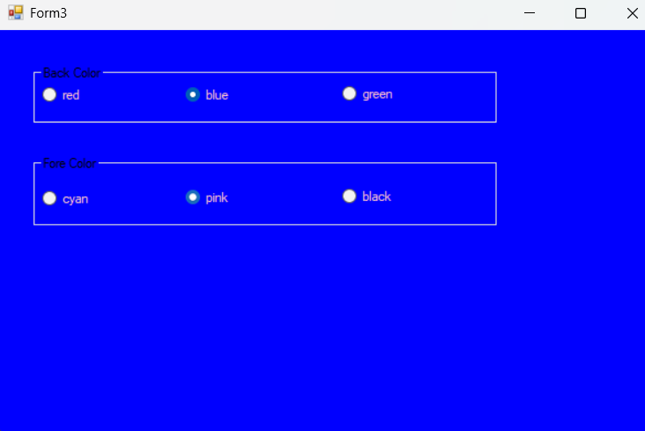

- Design a form like below. When user click on Answer button, selected operation performed on given two numbers and answer is displayed on as shown.
namespace First_Desktop_App
{
partial class Form3
{
/// <summary>
/// Required designer variable.
/// </summary>
private System.ComponentModel.IContainer components = null;

/// <summary>
/// Clean up any resources being used.
/// </summary>
/// <param name="disposing">true if managed resources should be disposed; otherwise, false.</param>
protected override void Dispose(bool disposing)
{
if (disposing && (components != null))
{
components.Dispose();
}
base.Dispose(disposing);
}

#region Windows Form Designer generated code

/// <summary>
/// Required method for Designer support - do not modify
/// the contents of this method with the code editor.
/// </summary>
private void InitializeComponent()
{
this.ADD_BTN = new System.Windows.Forms.Button();
this.label4 = new System.Windows.Forms.Label();
this.label3 = new System.Windows.Forms.Label();
this.textBox2 = new System.Windows.Forms.TextBox();
this.textBox1 = new System.Windows.Forms.TextBox();
this.SUB_BTN = new System.Windows.Forms.Button();
this.MUL_BTN = new System.Windows.Forms.Button();
this.DIV_BTN = new System.Windows.Forms.Button();
this.SuspendLayout();
//
// ADD_BTN
//
this.ADD_BTN.Location = new System.Drawing.Point(209, 175);
this.ADD_BTN.Name = "ADD_BTN";
this.ADD_BTN.Size = new System.Drawing.Size(75, 23);
this.ADD_BTN.TabIndex = 11;
this.ADD_BTN.Text = "+";
this.ADD_BTN.UseVisualStyleBackColor = true;
this.ADD_BTN.Click += new System.EventHandler(this.ENTER_BTN_Click_1);
//
// label4
//
this.label4.AutoSize = true;
this.label4.Location = new System.Drawing.Point(255, 116);
this.label4.Name = "label4";
this.label4.Size = new System.Drawing.Size(79, 16);
this.label4.TabIndex = 10;
this.label4.Text = "Enter Num 2";
//
// label3
//
this.label3.AutoSize = true;
this.label3.Location = new System.Drawing.Point(255, 66);
this.label3.Name = "label3";
this.label3.Size = new System.Drawing.Size(79, 16);
this.label3.TabIndex = 9;
this.label3.Text = "Enter Num 1";
this.label3.Click += new System.EventHandler(this.label3_Click);
//
// textBox2
//
this.textBox2.Location = new System.Drawing.Point(345, 110);
this.textBox2.Name = "textBox2";
this.textBox2.Size = new System.Drawing.Size(100, 22);
this.textBox2.TabIndex = 8;
//
// textBox1
//
this.textBox1.Location = new System.Drawing.Point(345, 63);
this.textBox1.Name = "textBox1";
this.textBox1.Size = new System.Drawing.Size(100, 22);
this.textBox1.TabIndex = 7;
//
// SUB_BTN
//
this.SUB_BTN.Location = new System.Drawing.Point(323, 175);
this.SUB_BTN.Name = "SUB_BTN";
this.SUB_BTN.Size = new System.Drawing.Size(75, 23);
this.SUB_BTN.TabIndex = 12;
this.SUB_BTN.Text = "-";
this.SUB_BTN.UseVisualStyleBackColor = true;
this.SUB_BTN.Click += new System.EventHandler(this.SUB_BTN_Click);
//
// MUL_BTN
//
this.MUL_BTN.Location = new System.Drawing.Point(424, 175);
this.MUL_BTN.Name = "MUL_BTN";
this.MUL_BTN.Size = new System.Drawing.Size(75, 23);
this.MUL_BTN.TabIndex = 13;
this.MUL_BTN.Text = "x";
this.MUL_BTN.UseVisualStyleBackColor = true;
this.MUL_BTN.Click += new System.EventHandler(this.MUL_BTN_Click);
//
// DIV_BTN
//
this.DIV_BTN.Location = new System.Drawing.Point(531, 175);
this.DIV_BTN.Name = "DIV_BTN";
this.DIV_BTN.Size = new System.Drawing.Size(75, 23);
this.DIV_BTN.TabIndex = 14;
this.DIV_BTN.Text = "/";
this.DIV_BTN.UseVisualStyleBackColor = true;
this.DIV_BTN.Click += new System.EventHandler(this.DIV_BTN_Click);
//
// Form3
//
this.AutoScaleDimensions = new System.Drawing.SizeF(8F, 16F);
this.AutoScaleMode = System.Windows.Forms.AutoScaleMode.Font;
this.ClientSize = new System.Drawing.Size(800, 450);
this.Controls.Add(this.DIV_BTN);
this.Controls.Add(this.MUL_BTN);
this.Controls.Add(this.SUB_BTN);
this.Controls.Add(this.ADD_BTN);
this.Controls.Add(this.label4);
this.Controls.Add(this.label3);
this.Controls.Add(this.textBox2);
this.Controls.Add(this.textBox1);
this.Name = "Form3";
this.Text = "Form3";
this.Load += new System.EventHandler(this.Form3_Load);
this.ResumeLayout(false);
this.PerformLayout();

}

#endregion

private System.Windows.Forms.Button ADD_BTN;
private System.Windows.Forms.Label label4;
private System.Windows.Forms.Label label3;
private System.Windows.Forms.TextBox textBox2;
private System.Windows.Forms.TextBox textBox1;
private System.Windows.Forms.Button SUB_BTN;
private System.Windows.Forms.Button MUL_BTN;
private System.Windows.Forms.Button DIV_BTN;
}
}

Output:-
